Robo Go User Manual

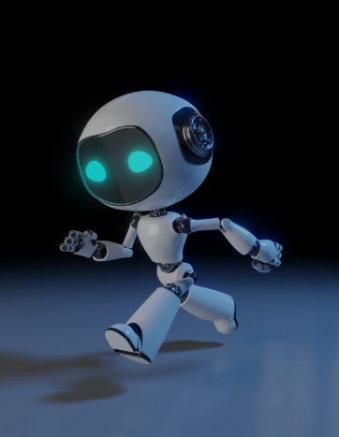

## **1. Welcome!**

Congratulations on getting your ROBO_GO Robot!

This model is called the Kats Robot v1.0. The purpose of this entry level robot is for tech hobbyists , innovators and people who are entering into the space of Robot Machine learning like you and me .

Your robot can:

* Move by itself (autonomous mode)
* Be controlled from your phone (manual mode)
* Avoid obstacles with sensors

This guide will help you set it up and start having fun safely.

## **2. What You Need**

* ROBO_GO app on your smartphone
* Bluetooth-enabled phone
* 12V Li-po batteries for the robot
* A clear space with a few obstacles to test it

## **3. Safety First**

* Keep the robot away from water
* Keep hair, clothes, and fingers away from the wheels
* Always watch younger kids while using the robot
* Don’t open or touch the electronics when the robot is on

## **4. Robot Parts**

| **Part** | **What it does** |
| --- | --- |
| ESP32 | Brain of the robot, controls everything |
| DC Motors | Makes the robot move |
| Ultrasonic Sensors | Detect walls or obstacles |
| LEDs | Show movement direction and obstacles |
| Battery | Powers the robot |
| Motor driver | To allows for precise control of the motor's speed, direction, and torque by manipulating the power and current it receives. |
| Battery Holder | To help the batteries stay in one place |

## **5. How to Set Up(since its been connected for you )**

1. **Insert Battery** – Connect your 9V battery to the robot.
2. **Turn On Robot** – Switch it on; LEDs should light up.
3. **Open ROBO_GO App** – Make sure Bluetooth is on.
4. **Connect Robot** – Tap the ESP32 name in the app to pair.

## **6. How to Use**

### **6.1 Manual Mode**

* Use buttons on the app to move forward, backward, left, or right.
* Control the robot like a remote car.

### **6.2 Command Mode**

* Send instructions like “Move Forward 50cm” or “Turn Left 90°”.
* The robot will follow these commands automatically.

### **6.3 Autonomous Mode**

* Turn on autonomous mode in the app.
* The robot will move on its own and avoid obstacles using sensors.

## **7. LED Lights**

* **Front LED** → Moving forward
* **Left/Right LEDs** → Detect obstacles on that side
* **Back LED** → Moving backward

## **8. Quick Troubleshooting**

| **Problem** | **Check This** |
| --- | --- |
| Robot won’t move | Battery connected? Switch on? |
| App doesn’t detect robot | Is Bluetooth on? Reopen app |
| Robot bumps into things | Are sensors blocked or dirty? |
| LEDs not working | Check wires and connections |

## **9. Take Care of Your Robot**

* Charge or replace battery when needed
* Keep sensors and wheels clean
* Store in a dry place
* Check wires before each use

## **10. Robot Specs**

* **Brains:** ESP32 and the Arduino Nano BLE
* **Motors:** DC, 6–9V
* **Sensors:** Ultrasonic HC-SR04 (Front, Left, Right)
* **Bluetooth:** BLE 4.2
* **Size:** 15 × 10 × 8 cm

Enjoy the EXPERIENCE OF THE ROBO_GO SYSTEM